HLD

Version
Version 1.0.4

SALT
Automated Emails
Automated Reports
Document Identification
Document Title | HLD Salt Automated Emails Automated ReportsUser Requirement SpecificationsUser Requirement Specifications
Author | John Hedlefs
Filename | 0000.doc
Version | Version 1.0.4
Modification Date | 30 Jun 2011
Version History
Version | Date | Author(s) | Details | Status
0.40 | 16 Feb 11 |  | Draft | Draft
0.41 | 22 Mar 11 |  | Draft | Draft
0.42 | 30 Mar 11 |  | Draft | Draft
0.43 | 1 Apr 11 |  | Draft | Draft
0.44 | 5 Apr 11 |  | Draft | Draft
0.45 | 6 Apr 11 |  | Draft | Draft
0.50 | 12 Apr 11 |  | Draft | Draft
1.0 | 14 Apr 11 |  | Accepted | Draft
1.0.2 | 20 Apr 11 |  | Development | Draft
1.0.4 | 30 Jun 11 |  | Development
Distribution List
Name | Role
Russel Duncan | CEO, Emerging Systems
Document Approval
Name |  | Date | Signature
Russel Duncan | Emerging Systems
Contents
1. Introduction 4
2. Automated Email Notification of SALTTM events 5
Software Architecture 5
The “Automated Mail Queuing Service” 6
Rules (SQL) to identify delinquent users 6
Rules (SQL) to identify users “At Risk” of becoming delinquent 7
Rules (SQL) to identify users with incomplete quiz results that are at risk of expiry 7
Warning users who have ‘passed’ quizzes in ‘incomplete’ courses on the ‘Due Date’. 14
Rules (SQL) to identify users who have recently passed a course 15
Identifying “New Starters” 15
Formatting of messages when multiple events occur. 15
Frequency of operation and threading. 15
The “Mail Sending Service” 17
Frequency of operation and threading. 17
Discussion of standards common to all Services. 18
Exception Handling 18
Inter-process communication 18
3. Date and Time recording and display in the users TimeZone. 18
Other issues 20
tblTimeZone 20
User created timezones 21
Ambiguous times 21
Stored Procedures 22
4. Periodic Report Delivery 23
The “Report Queuing Service” 25
5. New/Modified Screens 26
Personal Details 26
Organisation Details 27
Organisation Mail Setup 28
User’s Admin page 29
TimeZone screen (User Defined Timezone) 30
Periodic Report Delivery 33
Mail Throughput 34
Other modified screens 34
6. Proposed changes to the SALT Database structure. 35
7. New “Application Default” Messages on “Organisation Configuration” screen 38
8. Appendix 1 39
Sample TimeZone data taken from the Registry of a Windows PC. 39
TimeZone info for AUS Eastern Standard Time 39

Introduction

This document proposes a High Level Design for a Change Request to SALTTM, to allow the
- Automated sending of Email Alerts to users who are not meeting their suggested Course Completion dates and for other events.
- Automated sending of reports via Email to Administrators.
- User’s time zones to be configured and all user interaction to have timestamps in their nominated time zones.

This HLD describes:

- New technology (Windows Services)

- Proposed changes to SALT Screens and workflow.

- Proposed changes to the SALT Database structure.

Automated Email Notification of SALTTM events

Software Architecture
Supplying automated Email sending processes as Windows Services ensures that the processes are always restarted when the machine is restarted and the process has no “Main Form” that can be accidentally closed by operators that can remote into the server) so the processes involved in Automated sending of Emails will be provided as Windows Services.
Mail delivery in SALTTM v4.1.6 is done using System.Web.Mail, Microsoft recommends the use of System.Net.Mail instead of System.Web.Mail.
System.Net.Mail provides more features and is built on newer technology, one feature of interest for SALTTM 4.2.0 may be the ability to easily embed images in HTML (multipart) mail messages (to deliver Reports in HTML with graphs embedded) .

In regard to the sending of delinquency notification, two separate processes exist:
- identifying when an Email (or an Email to a number of recipients) should be sent and what is the contents of the Email.
- sending the Emails at a sufficiently low rate that Mail Server congestion will not occur.

Therefore two services are proposed:
- A service that periodically queues Emails for delivery is proposed, for the purposes of this Document it will be referred to as the “Mail Queuing Service”. *

- A service that sends the queued Emails, Records all mail sent and handles immediate failures to send, it will be referred to here as the “Mail Sending Service” or simple the “Sending Service”.

*Another service that queues reports for delivery is proposed in section 4

The Windows Services may be run on any Server that:
- Can run windows services
- has access to the SALTTM database (with a user account that has Stored Procedure execute permissions)
- has access to the mail server used for the sending of Emails

The “Automated Mail Queuing Service”

This service will queue all periodic notifications (delinquency, course expiry etc) to users and administrators.
The service should only run with an account that has SQL “Stored Procedure execute” permissions on the SALTTM database (The use of stored procedures limits the potential for SQL injection) . Delinquent users should be identified by stored procedures and flagged as notified as soon as the Email details have been queued. The Queue of Emails to be sent should also be held in the SALTTM database.

Wording of the Delinquency messages will not be localized however the messages may be customised for each Organisation.

As the Service sends (at most) a single Email message to each user per day warning them of delinquent Courses or Modules that are at risk of expiry it must only operate once per day per Organisation (after the overnight job updates course status for the Organisation).
The Overnight job (prcUserQuizStatusUpdate_Quick) will be modified so that it updates the CourseStatusLastUpdated field for an organisation (in tblOrganisation) immediately after it updates the Course Status information for an Organisation.
The “Mail Queuing Service” will update the DelinquenciesLastNotified field in tblOrganisation when it has queued notifications for all users in an Organisation.

The Overnight job should be run for each organisation at midnight in the Organisations timezone, this is the proposed schedule for the Overnight Job. An additional schedule is proposed - that the Overnight job be run for every organisation at midnight server time (as it currently does) to reduce the Overnight Jobs demand for SQL Server CPU during the hours of normally high CPU demand.

Organisations where the datepart of CourseStatusLastUpdated (ignoring hours) is a later date than the datepart of DelinquenciesLastNotified require processing by the “MailQueuing Service”.

Users in an organisation where tblbUserCourseDetails .NewContentModuleList is not null require notification of new content (set NewContentModuleList to null after notification).

Rules (SQL) to identify delinquent users

Emails are sent to the managers of users who have become delinquent each day.
Delinquent users in an Organisation have a course that is:
incomplete
and (tblUserCourseDetails.DelinquencyNotified = ‘False’)
and
(
(tblbUserCourseDetails.StartDate plus tblOrganisation.DelinquencyPeriod is less than today’s date)
)

tblbUserCourseDetails.DelinquencyNotified is updated by the “MailQueuingService” when an email is queued to inform a manager of a delinquency.

Rules (SQL) to identify users “At Risk” of becoming delinquent

Users are issued with a summary of all courses that they are currently nominated for (courses that are “At Risk” of delinquency will be identified as “At Risk” in the summary) every time a course becomes “At Risk”.
It is suggested that the summary show how many days the user has before delinquency for each “At Risk” course?
It is suggested that the summary also include quizes “At Risk” of expiry (see next section).

Users in an Organisation have a course that has become “At Risk” (and they have not been notified of the “At Risk” status) if they have a course that is:

incomplete
and (tblbUserCourseDetails.NumberOfDelinquencyNotifications < tblOrganisation.NumberOfReminders)
and (tblbUserCourseDetails.StartDate + tblOrganisation.DelinquencyPeriod –
(tblOrganisation.NumberOfReminders * tblOrganisation.DelinquencyReminderPeriod) < today’s date)
and (tblbUserCourseDetails.LastDelinquencyNotification is null or is less than (today’s date minus tblOrganisation.DelinquencyPeriod))

tblbUserCourseDetails.NumberOfDelinquencyNotifications and tblbUserCourseDetails.LastDelinquencyNotification are updated by the “MailQueuingService” when an email is queued to inform a user of a “Risk of delinquency”.

Rules (SQL) to identify users with incomplete quiz results that are at risk of expiry
Expiry is recalculated every day based on the rules in effect that day, warnings of expiry may be calculated on a slightly modified version of the expiry SQL.

Users are issued with a summary of all courses that they are currently nominated for (courses that have quizes that are “At Risk” are identified as being identified as “At Risk” in the summary) every time a quiz becomes “At Risk”.
It is suggested that the summary show how many days the quiz has before delinquency for each “At Risk” course?
It is suggested that the summary also include “At Risk of delinquency” (see previous section).

Users with a quiz result that is ‘at risk’ can be identified from this SQL (taken from the overnight job):
select cam.UserID,
cam.ModuleID,
cam.QuizFrequency,
cam.QuizPassMark,
cam.QuizCompletionDate
from
(
select
um.UserID,
um.ModuleID,
umr.QuizFrequency,
umr.QuizPassMark,
umr.QuizCompletionDate
from
(
Select
tU.UserID
, tU.FirstName
, tU.LastName
, tU.UnitID
, tU.OrganisationID
, tM.ModuleID
, tM.CourseID
, tC.Name ''CourseName''
, tM.Name
, tM.Sequence
, tM.Description
From
dbo.tblUser tU
--< get the courses a user has access to >--
Inner Join dbo.tblOrganisationCourseAccess tOCA
On tOCA.OrganisationID = tU.OrganisationID
--< get the course details >--
Inner join dbo.tblCourse tC
On tC.CourseID = tOCA.GrantedCourseID
--< get the Active modules in a course >--
inner join dbo.tblModule tM
On tM.CourseID = tC.CourseID
and tM.Active = 1
--< get the details on which moduels a user is configured to access >--
Left Outer join dbo.tblUserModuleAccess tUsrMA
On tUsrMA.UserID = tU.UserID
And tUsrMA.ModuleID = tM.ModuleID
--< get the details on which moduels a user''s Unit is excluded from >--
Left Outer Join dbo.tblUnitModuleAccess tUnitMA
On tUnitMA.UnitID = tU.UnitID
And tUnitMA.DeniedModuleID = tM.ModuleID
Where
tU.OrganisationID = @OrgID AND
tU.Active = 1
--< Active users only >--
and tu.UnitID is not null
--< Get the modules that the user''s Unit is not denied >--
and (tUnitMA.DeniedModuleID is null
--< and the user does not have special access to it>--
And tUsrMA.ModuleID is null)
--< or Get modules that the user has been specially granted
or tUsrMA.Granted=1
) um
inner join
(
Select u.UnitID,
m.CourseID,
m.ModuleID,
m.Name,
case
when ur.unitID is null then cast(1 as bit)
else cast(0 as bit)
end as UsingDefault,
case
when (ur.LessonFrequency is null and ur.LessonCompletionDate is null and o.DefaultLessonCompletionDate is null) then
o.DefaultLessonFrequency
else
ur.LessonFrequency
end
as LessonFrequency,
case
when (ur.QuizFrequency is null and ur.QuizCompletionDate is null and o.DefaultQuizCompletionDate is null) then
o.DefaultQuizFrequency
else
ur.QuizFrequency
end
as QuizFrequency,
isNull(ur.QuizPassMark, o.DefaultQuizPassMark) as QuizPassMark,
case
when (ur.LessonFrequency is null and ur.LessonCompletionDate is null and not(o.DefaultLessonCompletionDate is null)) then
o.DefaultLessonCompletionDate
else
ur.LessonCompletionDate
end
as LessonCompletionDate,
case
when (ur.QuizFrequency is null and ur.QuizCompletionDate is null and not(o.DefaultQuizCompletionDate is null)) then
o.DefaultQuizCompletionDate
else
ur.QuizCompletionDate
end
as QuizCompletionDate
From tblOrganisationCourseAccess c
inner join tblModule m
on m.CourseID = c.GrantedCourseID
inner join tblOrganisation o -- Get default compliance rules
on o.OrganisationID = c.OrganisationID
inner join tblUnit u
on u.OrganisationID = c.OrganisationID
left join tblUnitRule ur --Get the unit specific rules
on ur.ModuleID = m.ModuleID
and ur.UnitID=u.unitID
WHERE o.OrganisationID = @OrgID
) umr
on
umr.ModuleID = um.ModuleID
and umr.UnitID = um.UnitID
and um.UnitID in (select UnitID from tblUnit where OrganisationID = @OrgID)
and um.UserID IN (select UserID from tblUser where OrganisationID = @OrgID)
) cam
inner join
(
select
um.userID,
um.moduleID,
q.active,
qs.QuizScore,
qs.QuizSessionID,
qs.DateTimeCompleted
from
(

select
um.UserID,
um.ModuleID,
umr.QuizFrequency,
umr.QuizPassMark,
umr.QuizCompletionDate
from
(
Select
tU.UserID
, tU.FirstName
, tU.LastName
, tU.UnitID
, tU.OrganisationID
, tM.ModuleID
, tM.CourseID
, tC.Name ''CourseName''
, tM.Name
, tM.Sequence
, tM.Description
From
dbo.tblUser tU
--< get the courses a user has access to >--
Inner Join dbo.tblOrganisationCourseAccess tOCA
On tOCA.OrganisationID = tU.OrganisationID
--< get the course details >--
Inner join dbo.tblCourse tC
On tC.CourseID = tOCA.GrantedCourseID
--< get the Active modules in a course >--
inner join dbo.tblModule tM
On tM.CourseID = tC.CourseID
and tM.Active = 1
--< get the details on which moduels a user is configured to access >--
Left Outer join dbo.tblUserModuleAccess tUsrMA
On tUsrMA.UserID = tU.UserID
And tUsrMA.ModuleID = tM.ModuleID
--< get the details on which moduels a user''s Unit is excluded from >--
Left Outer Join dbo.tblUnitModuleAccess tUnitMA
On tUnitMA.UnitID = tU.UnitID
And tUnitMA.DeniedModuleID = tM.ModuleID
Where
tU.OrganisationID = @OrgID AND
tU.Active = 1
--< Active users only >--
and tu.UnitID is not null
--< Get the modules that the user''s Unit is not denied >--
and (tUnitMA.DeniedModuleID is null
--< and the user does not have special access to it>--
And tUsrMA.ModuleID is null)
--< or Get modules that the user has been specially granted
or tUsrMA.Granted=1
) um
inner join
(
Select u.UnitID,
m.CourseID,
m.ModuleID,
m.Name,
case
when ur.unitID is null then cast(1 as bit)
else cast(0 as bit)
end as UsingDefault,
case
when (ur.LessonFrequency is null and ur.LessonCompletionDate is null and o.DefaultLessonCompletionDate is null) then
o.DefaultLessonFrequency
else
ur.LessonFrequency
end
as LessonFrequency,
case
when (ur.QuizFrequency is null and ur.QuizCompletionDate is null and o.DefaultQuizCompletionDate is null) then
o.DefaultQuizFrequency
else
ur.QuizFrequency
end
as QuizFrequency,
isNull(ur.QuizPassMark, o.DefaultQuizPassMark) as QuizPassMark,
case
when (ur.LessonFrequency is null and ur.LessonCompletionDate is null and not(o.DefaultLessonCompletionDate is null)) then
o.DefaultLessonCompletionDate
else
ur.LessonCompletionDate
end
as LessonCompletionDate,
case
when (ur.QuizFrequency is null and ur.QuizCompletionDate is null and not(o.DefaultQuizCompletionDate is null)) then
o.DefaultQuizCompletionDate
else
ur.QuizCompletionDate
end
as QuizCompletionDate
From tblOrganisationCourseAccess c
inner join tblModule m
on m.CourseID = c.GrantedCourseID
inner join tblOrganisation o -- Get default compliance rules
on o.OrganisationID = c.OrganisationID
inner join tblUnit u
on u.OrganisationID = c.OrganisationID
left join tblUnitRule ur --Get the unit specific rules
on ur.ModuleID = m.ModuleID
and ur.UnitID=u.unitID
WHERE o.OrganisationID = @OrgID
) umr
on
umr.ModuleID = um.ModuleID
and umr.UnitID = um.UnitID
and um.UnitID in (select UnitID from tblUnit where OrganisationID = @OrgID)
and um.UserID IN (select UserID from tblUser where OrganisationID = @OrgID)

) um
inner join
(
select
um.userID, um.moduleID, max(DateTimeCompleted) as DateTimeCompleted
from
(

select
um.UserID,
um.ModuleID,
umr.QuizFrequency,
umr.QuizPassMark,
umr.QuizCompletionDate
from
(
Select
tU.UserID
, tU.FirstName
, tU.LastName
, tU.UnitID
, tU.OrganisationID
, tM.ModuleID
, tM.CourseID
, tC.Name ''CourseName''
, tM.Name
, tM.Sequence
, tM.Description
From
dbo.tblUser tU
--< get the courses a user has access to >--
Inner Join dbo.tblOrganisationCourseAccess tOCA
On tOCA.OrganisationID = tU.OrganisationID
--< get the course details >--
Inner join dbo.tblCourse tC
On tC.CourseID = tOCA.GrantedCourseID
--< get the Active modules in a course >--
inner join dbo.tblModule tM
On tM.CourseID = tC.CourseID
and tM.Active = 1
--< get the details on which moduels a user is configured to access >--
Left Outer join dbo.tblUserModuleAccess tUsrMA
On tUsrMA.UserID = tU.UserID
And tUsrMA.ModuleID = tM.ModuleID
--< get the details on which moduels a user''s Unit is excluded from >--
Left Outer Join dbo.tblUnitModuleAccess tUnitMA
On tUnitMA.UnitID = tU.UnitID
And tUnitMA.DeniedModuleID = tM.ModuleID
Where
tU.OrganisationID = @OrgID AND
tU.Active = 1
--< Active users only >--
and tu.UnitID is not null
--< Get the modules that the user''s Unit is not denied >--
and (tUnitMA.DeniedModuleID is null
--< and the user does not have special access to it>--
And tUsrMA.ModuleID is null)
--< or Get modules that the user has been specially granted
or tUsrMA.Granted=1
) um
inner join
(
Select u.UnitID,
m.CourseID,
m.ModuleID,
m.Name,
case
when ur.unitID is null then cast(1 as bit)
else cast(0 as bit)
end as UsingDefault,
case
when (ur.LessonFrequency is null and ur.LessonCompletionDate is null and o.DefaultLessonCompletionDate is null) then
o.DefaultLessonFrequency
else
ur.LessonFrequency
end
as LessonFrequency,
case
when (ur.QuizFrequency is null and ur.QuizCompletionDate is null and o.DefaultQuizCompletionDate is null) then
o.DefaultQuizFrequency
else
ur.QuizFrequency
end
as QuizFrequency,
isNull(ur.QuizPassMark, o.DefaultQuizPassMark) as QuizPassMark,
case
when (ur.LessonFrequency is null and ur.LessonCompletionDate is null and not(o.DefaultLessonCompletionDate is null)) then
o.DefaultLessonCompletionDate
else
ur.LessonCompletionDate
end
as LessonCompletionDate,
case
when (ur.QuizFrequency is null and ur.QuizCompletionDate is null and not(o.DefaultQuizCompletionDate is null)) then
o.DefaultQuizCompletionDate
else
ur.QuizCompletionDate
end
as QuizCompletionDate
From tblOrganisationCourseAccess c
inner join tblModule m
on m.CourseID = c.GrantedCourseID
inner join tblOrganisation o -- Get default compliance rules
on o.OrganisationID = c.OrganisationID
inner join tblUnit u
on u.OrganisationID = c.OrganisationID
left join tblUnitRule ur --Get the unit specific rules
on ur.ModuleID = m.ModuleID
and ur.UnitID=u.unitID
WHERE o.OrganisationID = @OrgID
) umr
on
umr.ModuleID = um.ModuleID
and umr.UnitID = um.UnitID
and um.UnitID in (select UnitID from tblUnit where OrganisationID = @OrgID)
and um.UserID IN (select UserID from tblUser where OrganisationID = @OrgID)

) um
inner join tblQuiz q
on q.ModuleID = um.ModuleID
inner join tblQuizSession qs
on
qs.QuizID= q.quizID
and qs.userID = um.userID
and qs.DateTimeCompleted is not null
group by um.userID, um.moduleID
)
as LastQuizDate

on
LastQuizDate.userID = um.userID
and LastQuizDate.ModuleID = um.ModuleID

inner join tblQuiz q
on
q.ModuleID = um.ModuleID
inner join tblQuizSession qs
on
qs.QuizID= q.quizID
and qs.userID = um.userID
and qs.DateTimeCompleted = LastQuizDate.DateTimeCompleted
) sm
on sm.UserID = cam.UserID
and sm.ModuleID = cam.ModuleID
where
(
(
cam.QuizCompletionDate is null
and DateDiff(day,getdate(), dateadd(month, cam.QuizFrequency, sm.DateTimeCompleted)) <= o.DaysWarningBeforeExpiry
)
or
(
isnull(DateDiff(day, getdate(), cam.QuizCompletionDate), 1) <= o.DaysWarningBeforeExpiry
)
)
and cam.UserID in (select UserID from tblUser where OrganisationID = @OrgID)

The list of modules in a course that have quizes that are ‘At Risk’ will be stored in tblUserCourseDetails.AtRiskQuizList (along with a flag indicating whether the user has been notified of the ‘At Risk’ status).

If this SQL is added to the Overnight job then it will be much smaller as the overnight job contains temp tables that replace large sections of this SQL so the solution will contain changes to the Overnight job to identify modules in a course that have quizes that are ‘At Risk’ (by updating tblUserCourseDetails.AtRiskQuizList).

The additional code to be added to the overnight job is expected to be:
insert into tblAtRiskOfQuizExpiry
(
UserID,
ModuleID,
)
select cam.UserID,
cam.ModuleID,
from #tblCurrentAssignedModules cam
inner join #tblStartedModules sm
on sm.UserID = cam.UserID
and sm.ModuleID = cam.ModuleID
where
(
(
cam.QuizCompletionDate is null
and DateDiff(day,getdate(), dateadd(month, cam.QuizFrequency, sm.DateTimeCompleted)) <= o.DaysWarningBeforeExpiry
)
or
(
isnull(DateDiff(day, getdate(), cam.QuizCompletionDate), 1) <= o.DaysWarningBeforeExpiry
)
)
The Overnight job will only update tblAtRiskOfQuizExpiry once per day (at midnight in the organisations timezone).

The “Mail Queuing Service” will add records to tblUserCourseDetails as required and will replace all values of tblUserCourseDetails.AtRiskQuizList for the organisation and the “Mail Queuing Service” will notify users of all course/quiz status when a quiz exists in tblUserCourseDetails.AtRiskQuizList when it does not exist in tblUserCourseDetails.NotifiedAtRiskQuizList.
After notifying the users the “Mail Queuing Service” will update tblUserCourseDetails.NotifiedAtRiskQuizList.

Warning users who have ‘passed’ quizzes in ‘incomplete’ courses on the ‘Due Date’.
A facility will be provided to enter a due date for all quizzes in an Organisation, a reminder will be sent on the ‘Due Date’ to all users who have passed a quiz but not the course.
Expiry warnings only relate to ‘passed’ quiz results that will be lost if the user does not complete the course by the due date, warnings will not be issued for courses in which no quizzes have been passed.

Users are issued with a summary of all courses that they are currently nominated for (courses that have quizes that are “At Risk” are identified as being identified as “At Risk” in the summary) on the due date.

It is suggested that the summary also include “At Risk of delinquency” (see previous section).

Rules (SQL) to identify users who have recently passed a course

Users are issued with an Email summary of all courses that they were nominated for that they have completed every day a course becomes completed.

Attached to this Email will be PDF versions of the Completion Certificates for all courses passed that day along with the login URL for salt so that they may login and reprint their certificates from the saltTM website.

It is suggested that the summary also include “At Risk of delinquency” and “At risk of Expiry” (see previous sections).

Users that have a record for the course in tblUserCourseDetails and a “passed” record in tblUserCourseStatus have not been congratulated for their passing a course.

After sending an email congratulating a user on passing a course the records in tblUserCourseDetails for which a “passed” record exists in tblUserCourseStatus will be deleted.

Identifying “New Starters”
Users are issued with a summary of all courses that they were nominated for during the previous day. If the ‘New starter flag’ is present then the wording of the message will be different and will include their username ,initial password and login URL for salt and should invite the user to change their password at their earliest convenience. When a user is added on the ‘Add User’ screen the password for the user will initially be populated with a Randomised Password, in addition a ‘Randomise Password’ button will be displayed that will allow a Random password to be generated. The ‘Randomise Password’ button will also be visible on the ‘User Details’ page and will function in the same manner. Randomised passwords will be 8 characters long and may contain the characters ‘a’..’z’, ‘A’..’Z’ ,’1’..’0’ and the characters $,@,!,%,&,*,(,),{,}. And the comma. Randomised passwords will not contain occurrences of more than 3 sequential alpha characters (‘a’..’z’, ‘A’..’Z’).

It is suggested that the summary also include “Passed courses” , “At Risk of delinquency” and “At risk of Expiry” summaries (see previous sections).

The NewStarterFlag is set by the ‘add user’ ASP webpage when a user is created and their initial password is entered (or imported then activated). Once an Email containing the Course name and completion date is generated the flag will be reset.

Notification of manually expired modules

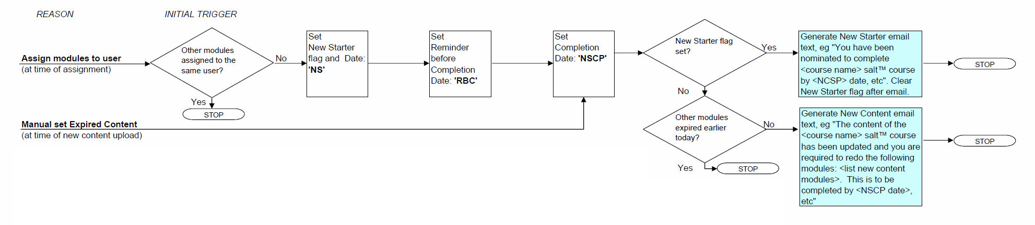
When a manager manually expires content (at time of new content upload) the logic from this diagram will be followed.

Formatting of messages when multiple events occur.
The messages contained in tblOrganisationConfig for some event types are designed to notify users of a list of courses for which a particular event has occurred. Three new Email templates are proposed:
- ‘Hi, The following list of modules (and respective courses) are At Risk of Expiry %Modules(Course)ExpiryDate%’
- ‘Hi, You have been nominated to complete %APP_NAME% %COURSENAMES% by %DelinquencyDate%’
- ‘Hi, You were nominated to complete %APP_NAME% %COURSENAMES% by %DelinquencyDate% however our records show that you have not completed these courses, please complete these courses as soon as possible’

N.B. %Modules(Course)ExpiryDate% is replaced with a list that may continue over many lines , for example:
Hi, The following list of modules (and respective courses) are At Risk of Expiry:
Creating 3D logos, displaying 3D images, creating 3D buttons (The basics of 3D websites) 1 May 2011
Identifying Devices, building small screen versions of a web page (Building a Mobile friendly Website) 1 May 2011
CPR, assessing the patient (First aid in the workplace) 1 May 2011

Frequency of operation and threading.
This service spawns no external processes (outside of the Server on which it runs and the Database Server) that would suggest multi-threading would improve it’s overall throughput significantly.

This Service could operate fairly frequently (every one to five minutes) as the service consumes few resources when it is fired when there are no Emails to be queued (a single stored procedure execution). The frequency of operation should be user configurable at the WebServer level (not for each Org) for the purposes of this document the rate at which this Service is called will be referred to as “MailQueueingCycleTime” .

When triggered this Service should repeatedly
- identify Users who have one or more notifications due
- queue an email describing the status of all of the users courses
- set flags (DateTime records) indicating that notification has been sent regarding all overdue courses and “at risk of expiry” modules
until it is unable to identify any Users that require notification – at which point it should go dormant and wait for a period of time equal to “MailQueueingCycleTime” before beginning its next cycle.

Settings such as “MailQueueingCycleTime” should be stored in the Registry, default values will be populated by the installer.

The “Mail Sending Service”
This service will take all queued Emails that are stored in the SALTTM database and transmit them using the correct Mail Account. The messages will be delivered as they are retrieved from the database with no language localisation.

Mail sent by any process (user registration, user completion, reminders and warnings) may queue email send requests to the Database and this service will deliver it, resend on failure and log it .

The service should only run with an account that has “Stored Procedure execute” permissions on the SALTTM database and sufficient privileges on the Mail server to send mail from any of the Unit/Org Admin Users Accounts. (The use of stored procedures limits the potential for SQL injection and other attacks)

The Service will be called at some predetermined frequency and will process a predetermined maximum number of emails (to prevent overloading the Mail Server that it sends requests to)

Errors that are immediately detected (say “user over quota” or POP server timeout) will be flagged against the job and the job will be marked for resending in 1 day. SALTTM will attempt to send jobs a maximum of 3 times, if the 3rd attempt to send a message fails the Organisation Administrator will be notified by Email (zero retry attempts) and the job will be removed from the send queue. Failed jobs may be added to the list of “Sent Email” providing a method of recording/displaying the delivery status of Emails is added to SALTTM .

Frequency of operation and threading.
Ideally the Service will never become Re-entrant (where the Service is Still processing the last batch of Emails when it is called on to process a new batch of Emails as this complicates some processes) so the timing mechanism will be disabled during the execution of the service and restarted the instant the service finishes processing the Emails (setting the new wait period to be the duration of one Cycle minus the Time already spent processing this instance).
Where there is heavy load and heavy network congestion there may not be sufficient time to send all emails synchronously so an asynchronous method of sending messages may be preferable.
Where there is light load and light network traffic synchronous delivery is preferable as if creates fewer mail jobs at any one time.

From a complexity/reliability standpoint it could be argued that a service must be as reliable as possible (it has no direct user interface and no user monitoring it when it becomes non-responsive) so it should be as simple as possible and in the First instance we should deliver a synchronous mail delivery service, and upgrade it to an asynchronous mail delivery Service only if this is absolutely necessary.

SMTP connections to the mail server should be kept alive between emails and only closed when the service exits.

Discussion of standards common to all Services.

Exception Handling
EVERY block of code in every service will have exceptions handled by inbuilt exception handling as there is no form for exceptions to be reported on.
Exceptions will be logged in the database (database exceptions will be logged in the Event log) using the same methods as SALTTM

Inter-process communication
The services will share the same database as SALT. (Transaction server).
The Datasource and password could be shared via the registry perhaps under the key HKEY_LOCAL_MACHINE \Software\BlakeDawson\SALT ? The installer will need to create the keys and grant write access for all users to the keys.
Other configuration data (normally stored in Web.config in the Website component of SALTTM) that should be stored in the Registry include:
- Log Errors to DB flag “Y” or “N”
- Event Log name
- ErrorLogEventName
- Deadlock retry info (“Y” or “N” ,minsecs, maxsecs, numretries)
- ReportServer URL, port and credentials

Passwords saved in the registry should be encrypted using the same algorithm as passwords in the web.config
The services will simply communicate with the database and SALT ASP.NET pages would provide all setup parameters to the service via the database (making debugging easier as the “communications” are visible to normal windows applications that can access the database). Default values should be saved in the database by the installer to enable the services to run “out of the box”.

Date and Time recording and display in the users TimeZone.

Dates and Times will be recorded in UTC in the database.

Dates and Times displayed to Administrators in Reports will be converted to the Timezone of the Organisation, this will require changes to the Reports. (Note to programmer - When changing non-Reporting Services Reports the solution that executes most quickly may be to perform the SELECT statements on search criteria converted to UTC then only convert the times in the output rows into the Organisations Timezone.)

Dates and Times displayed to non-Administrative users will be converted to the Timezone of the person viewing the Webpage (My training, My Report, certificates etc), this will require changes to those ASP.NET web pages. Certificates could have the timezone of the person printing the certificate shown along with the time so that when a user changes his timezone and reprints the certificate it is still a functionally (legally?) identical certificate.

Dates and Times entered by Administrators as report criteria on ASP.NET Reports need to be converted to UTC before being used in ad-hoc SQL or it should be converted to UTC within stored procedures when they are run, Dates and Times returned by ad-hoc SQL or stored procedures should be converted to the Administrators Timezones before being displayed (ie within the SQL/SP)

The following Web pages allow the entry of dates and the dates entered on these Web pages will require modification to convert them from the Organisations Timezone into UTC:
Form | Number of date controls on aspx page | Modify Input date ranges in Reporting Services Report (RS) or ASP page | Modify Output date ranges in Reporting Services Report (RS) or ASP page | Output date conversions on input parameters only (trivial)
cpddetail.aspx | 4 | RS | RS | Y
OrganisationDetails.aspx | ? | ASP? | SP/SQL? | ?
ComplianceRules.aspx | 4 | ASP? | SP/SQL? | ?
ArchiveUsers.aspx | 1 | ASP? | SP/SQL? | ?
Detail.aspx | 5 | ASP? | SP/SQL? | ?
AdministrationReport.aspx | 1 | ASP? | SP/SQL? | ?
ActiveInactiveReport.aspx | 2 | RS | RS | N
AtRiskReport.aspx | 2 | RS | RS | Y
CompletedUsersReport.aspx | 1 | RS | RS | Y
CompletedUsersReportDetail.aspx | 1 | RS | RS | Y
CourseStatusReport.aspx | 2 | RS | RS | N
CurrentAdminReport.rdl | 0 (Report RunAt Timestamp) | N/A | RS | Y
CurrentAdminReportByCourse.rdl | 0 (Report RunAt Timestamp) | N/A | RS | Y
LicensingReport.aspx | 1 (effectively) | RS | RS | Y
CPDReport.aspx | 1 | RS | RS | Y
Policies.rdl | 0 (Report RunAt Timestamp) | N/A | RS | N
ProgressReport.rdl | 0 (Report RunAt Timestamp) | N/A | RS | N
EmailSentReport.aspx | 1 |  | N/A
SummaryReport.aspx | 1 | RS | RS | Y
SummaryReportPie.rdl | 1 | RS | RS | Y
SummaryReportStackedBar.rdl | 1 | RS | RS | Y
SummaryReportStackedColumn.rdl | ? | RS | RS | Y
TrendReport.aspx | 2 | RS | RS | Y
UnitAdministratorReport.rdl | 0 (Report RunAt Timestamp) | N/A | RS | Y
UnitComplianceReport.rdl | 0 (Report RunAt Timestamp) | N/A | RS | Y
UnitPathReport.rdl | 0 (Report RunAt Timestamp) | N/A | RS | Y
UserDetail.rdl | 0 (Report RunAt Timestamp) | N/A | RS | Y
WarningReport.rdl | ? | N/A | RS | N
CompletedUsersReport.aspx | 1 | ASP? | SP/SQL? | ?
BuildEmailReport.aspx | 2 ? | ASP? | SP/SQL? | ?
policyemailreport.aspx | 4 | ASP? | SP/SQL? | ?
PolicyBuilderReport.aspx | 2 ? | ASP? | SP/SQL? | ?
TOTAL

All existing Timestamps will be converted to UTC by assuming they were saved in the timezone of the SQL Server on which they are stored. (see caveats on Ambiguous and Invalid times for a calendar with daylight saving)

All SQL and stored procedures that currently use getdate() will be modified to get the date in UTC.

Course expiry and delinquency will be deemed to occur at midnight in the Organisations Timezone.

In all new code it is proposed that in Emails to clients the expiry date be written so it includes the Organisations TimeZone –eg
- “before midnight 30 Dec 2011” may be assumed by many people to be before midnight 30 Dec 2011 in their local timezone (which may be a different point in time for many users).
- “before midnight 30 Dec 2011 AUS Eastern Standard Time ” is a distinct point in time for all users and is therefore the proposed standard language for saltTM Emails.

The Overnight job will (at a minimum) be run once per day for every Organisation at a time as soon as practicable after midnight in the Organisations Timezone. (Overnight Job workload may be arranged so that most processing will be done during the periods of low server activity with lower levels of processing done at other times). The Overnight job currently updates a single Organisation at a time so it only needs to be modified to expire courses in the correct (the organisations) TimeZone (it will currently expire all courses for all organisations in UTC+0:00 timezone), changes to the Overnight job will not be covered by this HLD.
The table tblUserCourseStatus is maintained by the Overnight Job so Delinquency Emails can not be sent until the Overnight Job performs an Organisations “midnight rollover” however delinquency Emails should still be sent shortly after Mignight for the Organisation.

Events in SALTTM will be recorded in UTC and converted to the users current TimeZone before being displayed, if the user moves to another Timezone historic events will be displayed in the new TimeZone (The displayed time for an event will be the time in the new TimeZone at which the event happened). Future events (such as course completion dates) will be converted to and recorded in UTC however they will be displayed as per other times (in the Organisations Timezones if the user is performing administrative tasks or in the users timezone if the user is performing non-administrative tasks). By quoting times with the TimeZone (For example 3:00 PM 30 Dec 2011 AUS Eastern Standard Time) any confusion would be removed.

Other issues
tblTimeZone
A windows based server (any windows installation) contains a list of timezones and the Daylight Saving Rules for all previous (and all known future) Daylight Saving schemes in those timezones in the registry that may be used as a current source of timezone data (see Appendix 1) it is the responsibility of the Server administrator to apply operating system updates that keep the Daylight saving information up to date.
The tables tblTimeZone and tblTimeZoneDaylightSavingRules will be created and will be populated with a list of TimeZones by the installer.
Each Organisation will have a TimeZone setting that is the default for all users in the Organisation. Users may nominate a timezone other than the Organisations Timezone.
When a user desires to change his/her TimeZone the browser can return the result of getTimezoneOffset() to the ASP.NET page and the ASP.NET page can use this information to suggest likely TimeZones from the list of all possible TimeZones (sorted by TimeZone offset).It is the responsibility of the Server administrator to apply operating system updates that keep the Daylight saving information up to date.

User created timezones
A facility will be provided for SALT Administrators to create new TimeZones manually and to re-import updated TimeZone information from the Registry of the Web-server. User created TimeZones will also be stored in the table tblTimeZone, any entry in the tblTimeZone for which the “StandardName” does not exist in the registry of the WebServer will be considered a “User created timezone”. “User created timezones” will not be affected by a re-import of timezones from the Webserver registry, all other timezones will be overwritten with data fromthe Webservers registry.
A new screen will be provided with controls to allow the administrator to create, edit and flag as “not shown” all TimeZones.
Ambiguous times
UTC is the native base time in Microsoft products and there are no ambiguous times in UTC (One argument for recording in UTC)

A date/time expressed as 17:00 AEDST 5 Jan 2011 provides a fairly accurate description of a point in time (02:15 AM on the day that clocks are set back is an ambiguous time as there are 2 occurrences (one hour apart) of all times between 02:00 and 03:00 on that day) whilst 02:15 on the day that clocks are set forward is an invalid time as the difference between 01:59:59 and 03:00:01 is only 2 seconds on that day) . Most SALTTM activities do not occur between 2 and 3 AM so invalid and ambiguous times in Historic data are not considered big problem. Any TimeStamps that are ambiguous will be assumed to have occurred in the first possible timeslice.

Stored Procedures
The following Stored Procedures are likely to require modification to use the
Organisations (or users) TimeZone in:
- prcLessonSession_StartLesson
- prcReport_CourseStatusReport
- prcEmail_LogSentEmail
- prcUserCourseStatus_insert
- prcUserQuizStatus_UpdateCourseStatus
- prcLessonSession_BeforeStartLesson
- prcModule_Create
- prcUser_Create
- prcUserQuizStatus_FIX
- prcReport_Warning
- prcQuizSession_UpdateEndQuizInfo
- prcUser_Import
- prcPolicy_Add
- prcQuizSession_BeforeStartQuiz
- prcProfilePeriod_RollOver
- prcQuizSession_StartQuiz
- prcCPDEmail_Report
- prcLessonSession_EndLesson
- prcQuizSession_EndQuiz
- prcCPDProfileHistory_Report
- prcCPDPoints_UpdateUser
- prcCPDPoints_Update
- prcCPDModuleHistory_Report
- prcCPD_CurrentPoints
The following Stored Procedures may require modification to use the
Organisations (or users) TimeZone:

- prcPolicy_Update ?
- prcUserQuizStatus_Update_Quick?
- prcUserLessonStatus_Update_Quick?
- prcReport_WarningGrandTotal?
- prcProfilePoints_Update?
- prcProfilePoints_Add?

.NET code can apply TimeZone information that seamlessly handles Daylight saving time in users timezones however SQL functions that handle timezones require daylight saving changes to be calculated by an external source when more than one timezone is involved.

SALTTM Stored Procedures use the SQL server getdate() function in at least 99 separate places, these calls will have to be changed to calls that handle the TimeZone (and daylight saving) correctly. The OrganisationID will be passed to all stored procedures that save or return Timestamps and the correct time will be calculated from the data in tblTimeZoneDaylightSavingRules.

Periodic Report Delivery

A new form will be created where administrative users can set up schedules for receiving Reports automatically at fixed intervals, the form will contain the following fields:
- How often to run (an integer number of days or months) eg every 7 days or every 1 month.
- The day the report starts on.
- A “Report Type” listbox that contains a list of every report that can be run from the Menu as well as a new report (Email Delivery Status percentage by user)
- The following “Report Criteria” controls that may be hidden or shown as is appropriate (as defined in tblReportInterface) for the report (consider using listboxes instead of radiobuttons to reduce form size).

Field Name | Control Type | Values
Report Style | Listbox or radio buttons? | Table,Stacked Column Chart, Pie Chart
Status | Listbox or radio buttons? | Complete,Incomplete, Incomplete(with details)
Fail Counter | Integer edit
Courses | Mutiselect listbox | Courses currently licensed
Historic Courses | Mutiselect listbox | Any Course allocated to the Org at any time
Units | Multiselect treeview with checkboxes? | All units currently in Org.
Expired (Time Elapsed) in | Integer edit with day/month spinner
Quiz status | Listbox or radio buttons? | Complete,Incomplete,Fail,Not Started, Expired(Time Elapsed), Expired(New Content)
Group by | Listbox or radio buttons? | Unit/User,Course
Grouping option | Listbox | Any or list of available options
First Name | edit
Last Name | Edit
User Name | Edit
Email | Edit
Include Inactive Users | checkbox
Subject: | Edit
Body: | Edit
Date To | DD-MM—YYYY + calendar
Date From | DD-MM—YYYY + calendar
Profile | Listbox | List of available profiles
Show only users with Shortfall | Checkbox
- A listbox showing all available Report formats (at least CSV attachment, Excel attachment and PDF attachment , HTML4.0 body with embedded PNG images (for charts), and possibly DOC) .

Rendering extensions provided by Reporting Services 2008 (sample)
Name: XML | type: XML file with report data
Name: NULL | type: NullRenderer
Name: CSV | type: CSV (comma delimited)
Name: PDF | type: Acrobat (PDF) file
Name: RGDI | type: Remote GDI+ file
Name: HTML4.0 | type: HTML 4.0
Name: MHTML | type: MHTML (web archive)
Name: EXCEL | type: Excel
Name: RPL | type: RPL Renderer
Name: IMAGE | type: TIFF file
Name: WORD | type: Word

Rendering extensions provided by Reporting Services 2008 R2 (sample)
Name: ATOM | type: Data Feed
Name: XML | type: XML file with report data
Name: NULL | type: NullRenderer
Name: CSV | type: CSV (comma delimited)
Name: PDF | type: PDF
Name: RGDI | type: Remote GDI+ file
Name: HTML4.0 | type: HTML 4.0
Name: MHTML | type: MHTML (web archive)
Name: EXCEL | type: Excel
Name: RPL | type: RPL Renderer
Name: IMAGE | type: TIFF file
Name: WORD | type: Word

- A grid with “New”, “Edit”, “Delete”, “Cancel” and “Save” buttons. The grid will show a list of the schedules for Automated Reports for the logged-in user. Selecting a row in the grid will cause the relevant “Report Criteria” controls to be shown and populated with the values relating to the (“Report type” of the) selected schedule (non-relevant controls will be hidden). Pressing the “Edit” button will make the “Report Criteria” controls (and other controls except “Report Criteria”) editable, the “Save” or “Cancel” button must be pressed to save changes before navigating to another row in the table. Pressing the “New” button will add a new row to the grid and make all controls editable (including “Report Type”) , the “Save” or “Cancel” button must be pressed to save changes before navigating to another row in the table. Pressing the “Delete” button will delete the row (subject to a confirmation dialog).

The “Report Queuing Service”

This service will queue all periodic reports to administrators.
The service should only run with an account that has SQL “Stored Procedure execute” permissions on the SALTTM database (The use of stored procedures limits the potential for SQL injection) .

Report schedules contained in tblReportSchedule will be periodically examined and any reports that are scheduled to be run will be executed against the MSSQL Reporting Services Report Execution Service. The resulting Report will (depending on the chosen format) will be saved in the body and/or attachment/s field in tblEmailQueueLinkedResource and tblEmailQueue.

To prevent too much demand from being placed on the Reporting Services Server the Service will only render one report at a time.

New/Modified Screens

Personal Details
Administrators will be provided with an additional field for the entry of email addresses, the email address with a label of ‘Email’ will always be used in the “Sender” field of emails sent by the administrator and will be used in the “From” field if it is the only email address specified, the email address with a label of “Email in Organisation Domain” may (optionally) be entered and will be used as the “From” address (if provided). If the BlakeDawson.com.au domain has an SPF record in the DNS of FlightCentre.com then the resulting mail will (for the most part) appear to have been sent by john.smith@FlightCentre.com however it is clearly identified as having come from “jsmith@BlakeDawson.com.au on behalf of john.smith@FlightCentre.com” so it is much less likely to be filtered by spam filters.
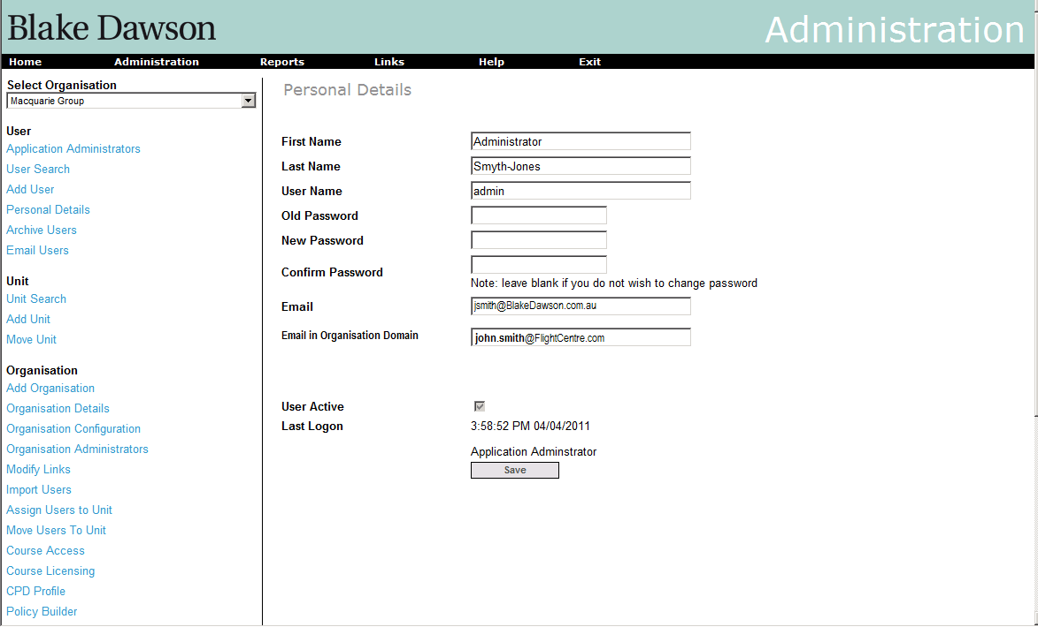

Organisation Details
A control to allow the Timezone for the entire Organisation to be set will be provided, the installation program will default all Organisation Timezones to ‘AUS Eastern Standard Time’ and the “New Organisation” process will ensure a Timezone is set by the Administrator however the Organisation Details screen will still check for the existence of a stored TimeZone and will display ‘AUS Eastern Standard Time’ if it has not been set (saving the page would then set the TimeZone) . When the user presses the “arrow” on the timezone control a list of all available TimeZones (see appendix1) will be displayed and will default the selected item to the TimeZone returned by the browser ( getTimezoneOffset() if this TimeZone differs from their existing timezone).

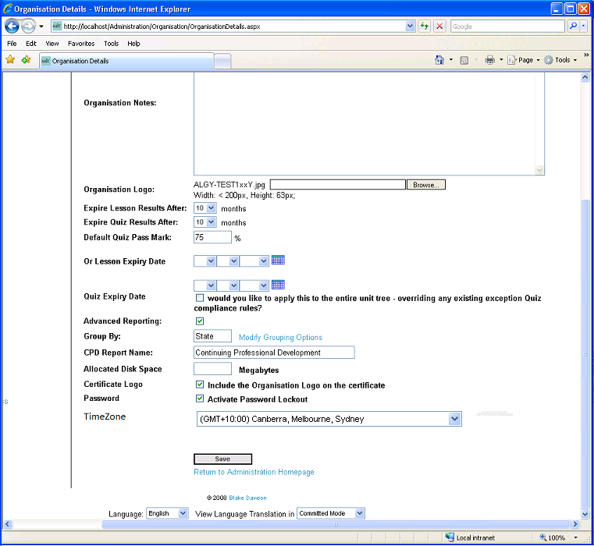

Organisation Mail Setup
Controls will be provided for the entry of delinquency and expiry-warning periods:
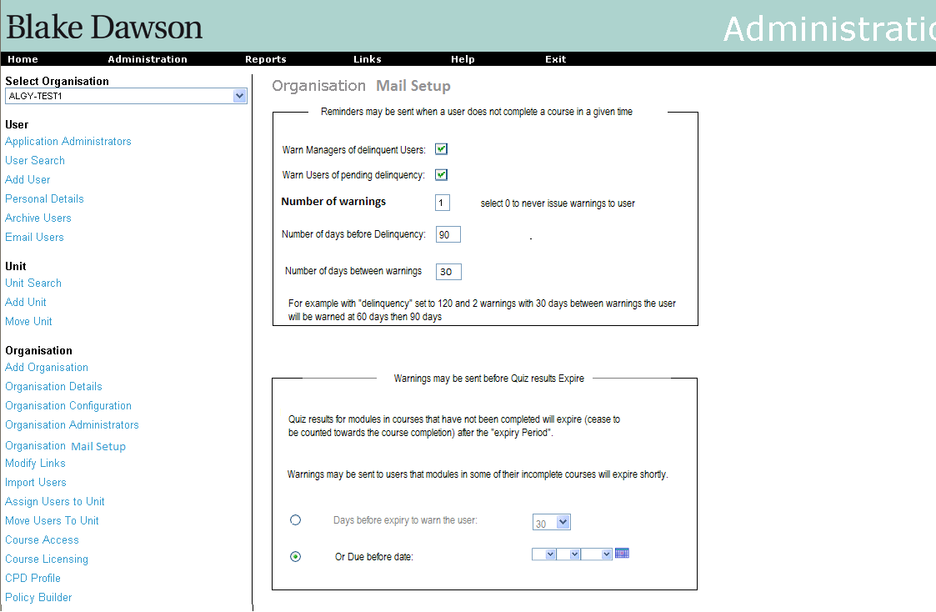

User’s Admin page
The users Admin page will require a facility for viewing and setting the TimeZone and a facility to opt out of Delinquency notifications. The “Manager to notify of delinquencies” control is only visible to administrators – i.e. it will only be visible on the “Users Details” screen not on the “Personal Details” screen.

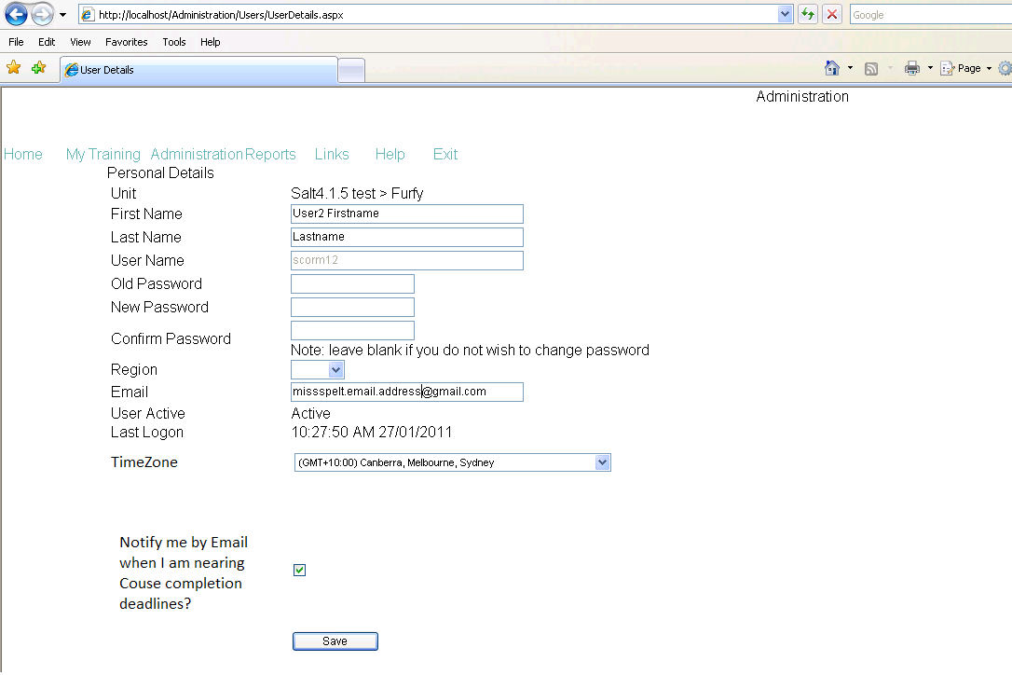

User Details page for an Administrator showing Timezone and “Manager to notify of delinquencies” controls:
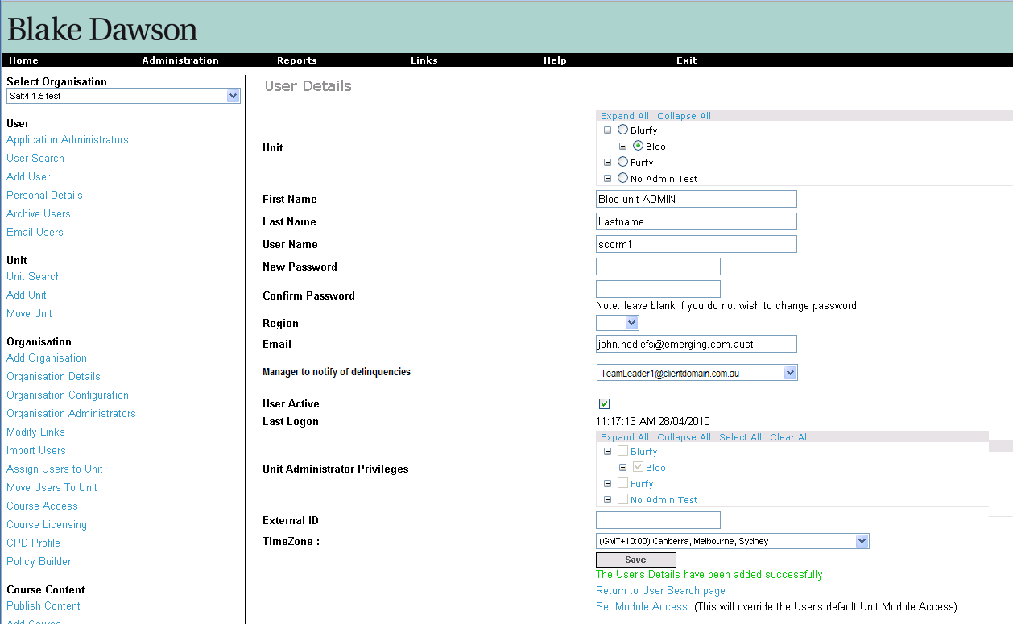

TimeZone screen (User Defined Timezone)
A screen will be provided to allow the entry of new timezones or localizations of Server TimeZones (where the server language differs from the Organisations language) which are also stored in the tblTimeZone table.
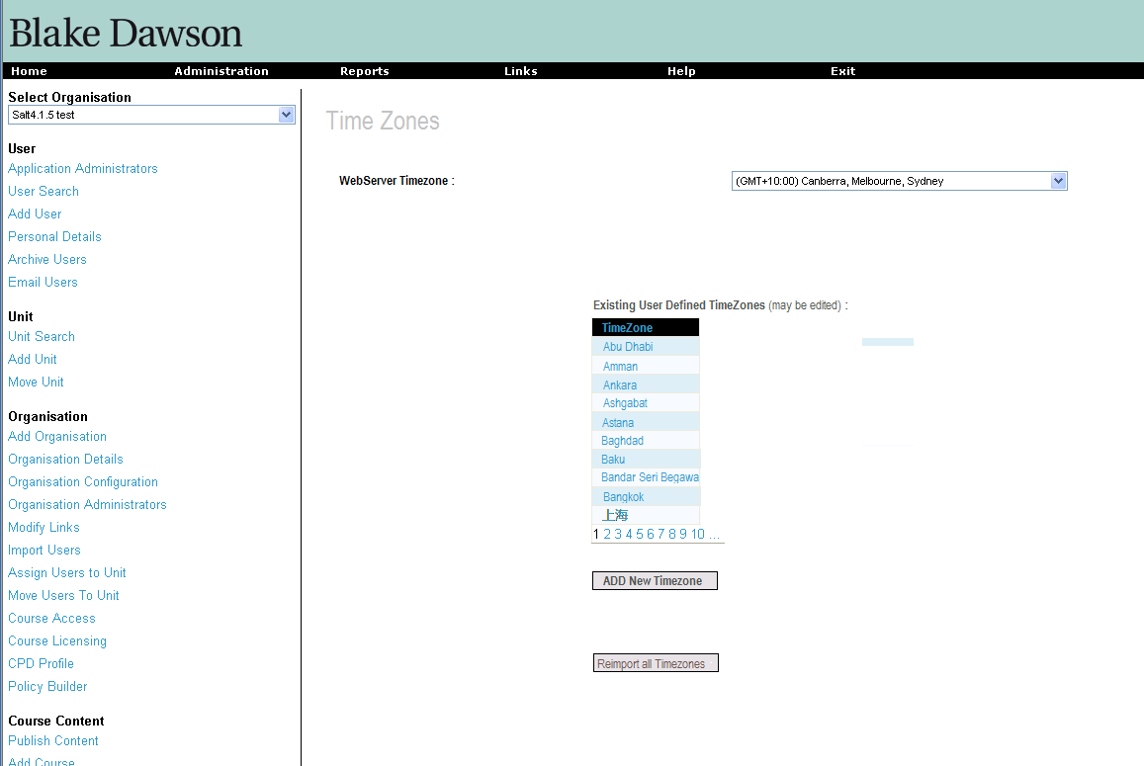
Pressing the ‘Re-import All Timezones” button will replace all timezones (and their daylight saving rules) whose names match a StandardName from the List of Timezones in the Registry of the Web Server with the data currently in the registry of the Web Server, this allows for updates supplied by Microsoft to be automatically applied to SALT. A sufficiently strongly worded warning should allow the user to reconsider updating the timezone data when they press this button.

Pressing the “Add New Timezone” button or clicking on the name of an existing User Defined TimeZone will take the Administrator to the Edit Time Zone screen:
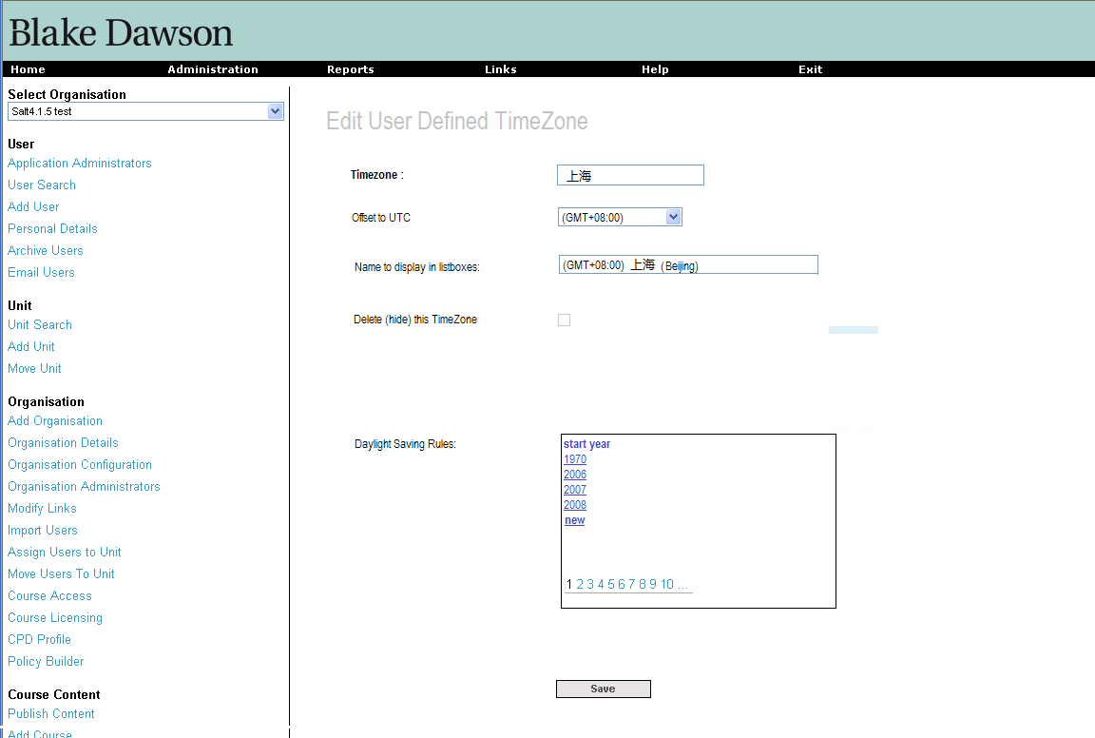
The name of the timezone (equates to StandardName in Microsoft parlance) may be edited.
The Timezone also has an editable “Name to display in listboxes” field (which equates to DisplayName in Microsoft Registry)
The “Offset to UTC” control will contain a list of all offsets in half hourly intervals from GMT +0.00 to GMT -11:30.
When a user selects the start year for a daylight saving rule from the list of daylight saving rules (or if they press new) they will be taken to the “Edit daylight saving Rules” page:
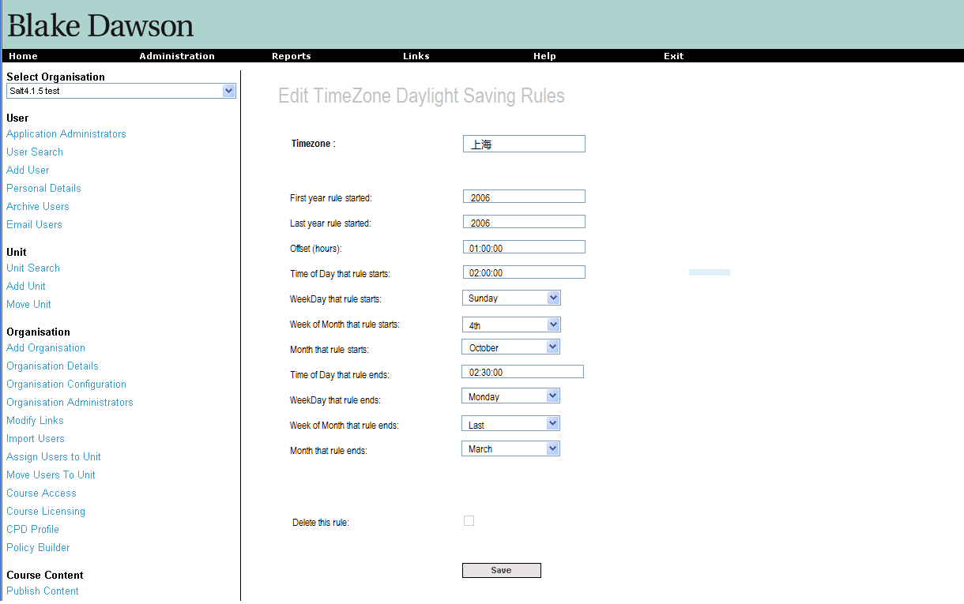

The offset (and “Time of Day” controls) must be filled with a duration comprising a (positive or negative) whole number of minutes (15 minute intervals is usually the smallest for most regional authorities).
The “Weekday” control will be populated with a list of days from ‘Sunday’ through ‘Saturday’.
The “Week of Month” control will be populated with the list ‘1st’,’2nd’,’3rd’,’4th’ and ‘Last’.
The “Month” control will be populated with a list of the months ‘January’ through ‘December’.
Logic will be provided to prevent the saving of overlapping rules and to force the entry of required fields. No real cases exist where there are two daylight saving rules starting in the same year however the interface will allow for this possibility so long as the periods do not overlap. Years outside the range 1970 to 2999 will be saved as a value within this range.
Offset times entered as (positive or negative) integers or floating point numbers will be converted to the hh:mm:ss format and rounded to the nearest minute before saving (seconds are not saved).
Pressing the “save” button will save the data entered and return to the “Edit User Defined Timezone” page.
“Time Of Day” controls are in 24 hour time i.e. 1 PM is 13:00:00

Periodic Report Delivery

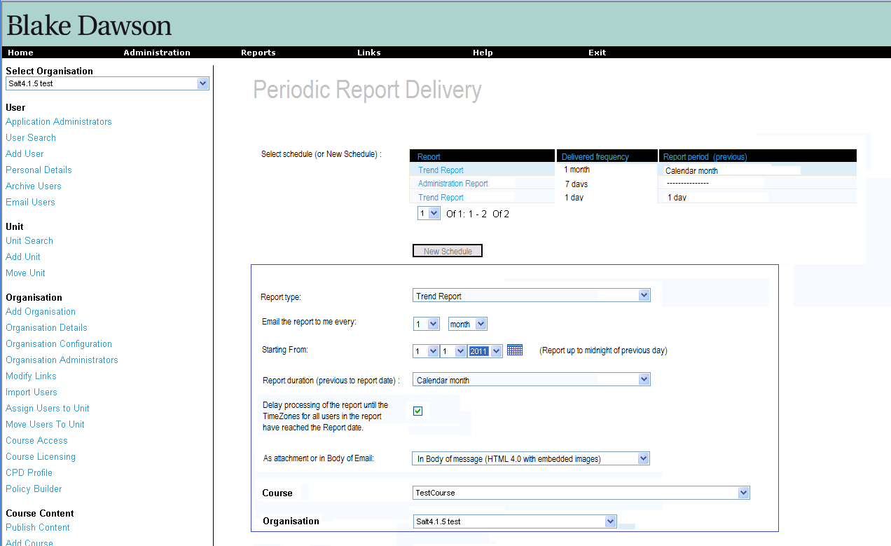
The table tblReportInterface contains definitions of what controls to display on this screen whereas the schedules created/edited by this screen are stored in the table tblReportSchedule. When a new Reporting Services report is added to the SALT website a new record should be added to the table tblReportInterface so that schedules may be created to deliver the Report periodically.
Mail Throughput
The Mail throughput screen allows the user to display a list of Organisations and (for each Organisation) these values:
- Number of Emails sent in the last hour
- Number of Emails sent in the last 24 hours
- Percentage of expected emails sent in the last day
The Percentage is calculated on the average workload for the current 1 hour timeslice (averaged over the last 7 days).
When the Percentage is in the range 10%=500% it will be displayed in a black font otherwise it will be displayed in a red font.
Clicking on a cell in the grid will drill-down to the Email report for the Organisation for either the last 1 hour or last 24 hours.
Clicking on a column name will order by the contents of that column (clicking again will toggle ascending/descending)
The page will refresh itself every 30 seconds.
The default sort order will be by “% of expected daily” descending – i.e. with highest values at the top.

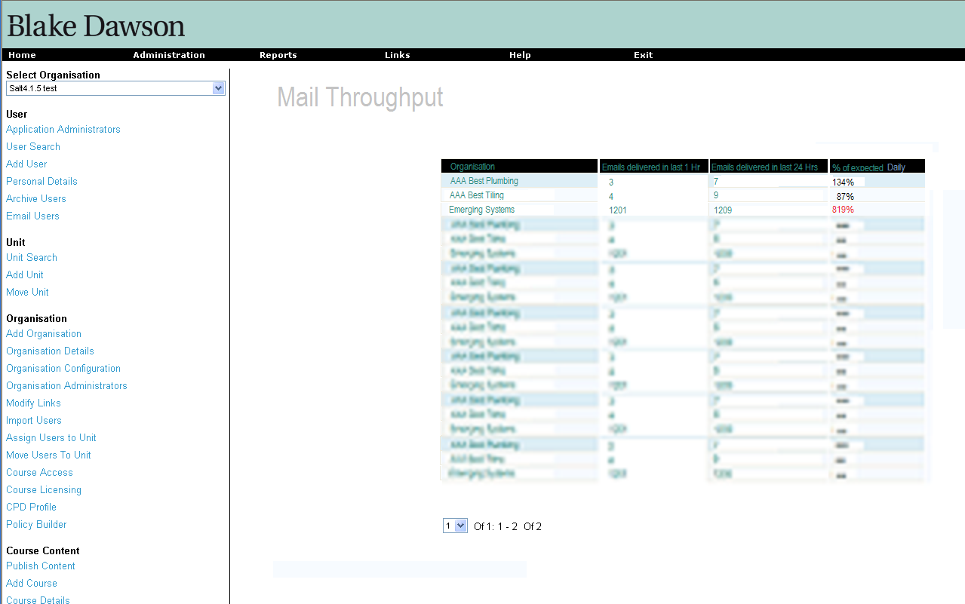
Values shown as "blurred" in the sample will be displayed accurately in the actual report.

Other modified screens
Many other screens will be modified however they will not have visible changes, a full list is not available at this time.

Proposed changes to the SALT Database structure.
Table Name | Added Field Name | Field Type | Allow Nulls | Default value (or comment)
tblOrganisation | MailServerURL | nvarchar(200) | yes
tblOrganisation | MailSendAccount | nvarchar(200) | yes
tblOrganisation | DelinquencyManagerID | int | yes
tblOrganisation | DelinquencyPeriod | int | no | 90
tblOrganisation | DelinquencyReminderPeriod | int | no | 30
tblOrganisation | NumberOfReminders | int | no | 0
tblOrganisation | TimeZoneID | int | yes
tblOrganisation | CourseStatusLastUpdated | DateTime | no | Dateadd(day,1,getdate())
tblOrganisation | DelinquenciesLastNotified | DateTime | no | Dateadd(day,1,getdate())
tblOrganisation | DaysWarningBeforeExiry | int | no | 0
tblUser | AcceptsDelinquencyEmails | bit | no | 0
tblUser | TimeZoneID | int | yes
tblUser | ModuleAtRiskCount | int | no | 0
tblEmailQueue | EmailQueueID | longInt | No | AutoIncrement
tblEmailQueue | organisationID | int | yes
tblEmailQueue | AddressTo | nvarchar(255) | Yes
tblEmailQueue | AddressBCCs | nvarchar(max) | Yes
tblEmailQueue | Subject | nvarchar(255) | Yes
tblEmailQueue | body | nvarchar(max) | Yes
tblEmailQueue | QueuedTime | datetime | no | getdate()
tblEmailQueue | SendStarted | datetime | Yes
tblEmailQueue | AddressSender | nvarchar(255) | Yes
tblEmailQueue | AddressFrom | nvarchar(255) | Yes
tblEmailQueue | IsHTML | bit | no | 0
tblEmailQueueLinkedResource | EmailQueueID | char(10) | no
tblEmailQueueLinkedResource | ContentID | char(10) | no
tblEmailQueueLinkedResource | Content | nvarchar(max) | no | “”
tblUserCourseDetails | NumberOfDelinquencyNotifications | int | No | 0
tblUserCourseDetails | NewStarterFlag | bit | yes
tblUserCourseDetails | AtRiskQuizList | Nvarchar(max) | no | ‘’
tblUserCourseDetails | NotifiedAtRiskQuizList | Nvarchar(max) | no | ‘’
tblUserCourseDetails | LastDelinquencyNotification | DateTime | yes
tblTimeZone | TimeZoneID | int | no
tblTimeZone | StandardName | nvarchar(60) | no
tblTimeZone | OffsetUTC | int | no
tblTimeZone | Alias | nvarchar(60) | no
tblTimeZone | Hidden | bit | No | False
tblReportSchedule | ScheduleID | int | no | Autoincrement (int on RS)
tblReportSchedule | UserID | int | no | @AdminUserID
tblReportSchedule | ReportID | int | no
tblReportSchedule | ParamOrganisationID | int | no | @OrganisationID
tblReportSchedule | LastRun | DateTime | yes
tblReportSchedule | ReportDuration | int | no
tblReportSchedule | ReportDurationPeriod | char | no | ‘D’,’W’,’M’,’Y’
tblReportSchedule | ReportStartDate | DateTime | no
tblReportSchedule | ReportFrequency | int | no
tblReportSchedule | ReportFrequencyPeriod | char | no | ‘D’,’W’,’M’,’Y’
tblReportSchedule | DocumentType | char | no | ‘P’ = PDF , ‘D’ = DOC, ‘E’ = EXCEL, ‘H’ = HTML (with embedded images), ‘C’ = CSV
tblReportSchedule | ParamCompleted | char | yes | ‘Y or ‘N’
tblReportSchedule | ParamStatus | char | yes | ‘C’,’I’,’D’
tblReportSchedule | ParamFailCount | int | yes
tblReportSchedule | ParamCurrentCourseIDs | varchar(2000) | yes
tblReportSchedule | ParamHistoricCourseIDs | varchar(2000) | yes
tblReportSchedule | ParamUnitIDs | varchar(MAX) | yes
tblReportSchedule | ParamAllUnits | char | yes | ‘Y or ‘N’
tblReportSchedule | ParamTimeExpired | int | yes
tblReportSchedule | ParamTimeExpiredPeriod | char | yes | ‘D’,’W’,’M’,’Y’
tblReportSchedule | ParamQuizStatus | char | yes | ‘C’,’I’,’F’,’N’,’T’,’E’
tblReportSchedule | ParamGroupBy | char | yes | ‘U’,’C’
tblReportSchedule | ParamGroupingOption | int | yes | classificationID
tblReportSchedule | ParamFirstName | nvarchar(200) | yes
tblReportSchedule | ParamLastName | nvarchar(200) | yes
tblReportSchedule | ParamUserName | nvarchar(200) | yes
tblReportSchedule | ParamEmail | nvarchar(200) | yes
tblReportSchedule | ParamIncludeInactive | char | yes | ‘Y or ‘N’
tblReportSchedule | ParamSubject | nvarchar(200) | yes
tblReportSchedule | ParamBody | nvarchar(200) | yes
tblReportSchedule | ParamProfileID | int | yes
tblReportSchedule | ParamOnlyUsersWithShortfall | char | yes | ‘Y or ‘N’
tblReportInterface | ReportID | int | no | Autoincrement (int on RS)
tblReportInterface | ReportName | nvarchar(200) | no | @rptTitle
tblReportInterface | RDLname | nvarchar(200) | no
tblReportInterface | RequiresParamCompleted | bit | no | @completed
tblReportInterface | RequiresParamStatus | bit | no | @rptComplete, @rptInComplete
tblReportInterface | RequiresParamFailCount | bit | no | @failCounter
tblReportInterface | RequiresParamCurrentCourseIDs | bit | no | @CourseIDs
tblReportInterface | RequiresParamHistoricCourseIDs | bit | no | 0
tblReportInterface | RequiresParamUnitIDs | bit | no | @unitIDs
tblReportInterface | RequiresParamAllUnits | bit | no | @allUnits
tblReportInterface | RequiresParamTimeExpired | bit | no | 0
tblReportInterface | RequiresParamTimeExpiredPeriod | bit | no | 0
tblReportInterface | RequiresParamQuizStatus | bit | no | @rptExpiredNew, @rptExpiredTime
tblReportInterface | RequiresParamGroupBy | bit | no | 0
tblReportInterface | RequiresParamGroupingOption | bit | no | 0
tblReportInterface | RequiresParamFirstName | bit | no | @userFirstName
tblReportInterface | RequiresParamLastName | bit | no | @userLastName
tblReportInterface | RequiresParamUserName | bit | no | @userName
tblReportInterface | RequiresParamEmail | bit | no | @rptEmail  @userEmail
tblReportInterface | RequiresParamIncludeInactive | bit | no | @IncludeInactive  @inclInactive
tblReportInterface | RequiresParamSubject | bit | no | 0
tblReportInterface | RequiresParamBody | bit | no | 0
tblReportInterface | RequiresParamDateTo | bit | no | @ToDate
tblReportInterface | RequiresParamDateFrom | bit | no | @FromDate
tblReportInterface | RequiresParamProfileID | bit | no | 0
tblReportInterface | RequiresParamOnlyUsersWithShortfall | bit | no | 0
tblReportInterface | ParamLangInterfaceName | varchar(200) | no | @LangInterfaceName
tblReportInterface | RequiresParamEffectiveDate | bit | no | @effectiveDate
tblReportInterface | RequiresParamSortBy | bit | no | @sortBy
tblReportInterface | RequiresParamClassificationID | bit | no | @classificationID

New “Application Default” Messages on “Organisation Configuration” screen

Description | Value | Comment
Student Summary Header | Hi, Our Records show that the following changes have occured to your course status for %APP_NAME%:
Student Summary Sig | Regards,%APP_NAME% Administrator
Student Summary - New Courses | You have been nominated to complete the following courses:
Student Summary -Passed Courses | Congratulations on passing the following courses:
Student Summary - Passed Modules | Congratulations on passing the following modules:
Student Summary - At Risk Of Expiry | Your quiz results for the following Courses (Modules) will expire unless you complete the entire course before the dates shown:
Student Summary - At Risk Of Delinquency | You were nominated to complete the following courses before the dates shown however our records indicate that the courses are not finished at this time. Please ensure that the courses are finished by the nominated dates:
Student Summary Message Subject | %APP_NAME% Summary.
Delinquency Summary Header | Hi, The Following students are now delinquent for their %APP_NAME% courses:
Delinquency Summary Sig | Regards,%APP_NAME% Administrator
Delinquency Summary Message Subject | %APP_NAME% Delinquency Summary.

Appendix 1

Sample TimeZone data taken from the Registry of a Windows PC.
The.NET TimeZoneInfo.GetSystemTimeZones() function returns a list of all TimeZones known at the last time the computers TimeZones were updated. This function will be called on the Web Server by ASP.NET code to return a list of TimeZones from which the Organisation Manager (or the User) can select from.

TimeZone info for AUS Eastern Standard Time
(as recorded in a sample developer PC)

ID: AUS Eastern Standard Time
Display Name: (GMT+10:00) Canberra, Melbourne, Sydney
Standard Name: AUS Eastern Standard Time
Daylight Name: AUS Eastern Daylight Time ***Has Daylight Saving Time***
Offset from UTC: 10 hours, 0 minutes
Number of adjustment rules: 2
Adjustment Rules:
From 1/01/0001 12:00:00 AM to 31/12/2007 12:00:00 AM
Delta: 01:00:00
Begins at 2:00 AM on Sunday of week 5 of October
Ends at 3:00 AM on Sunday of week 5 of March
From 1/01/2008 12:00:00 AM to 31/12/9999 12:00:00 AM
Delta: 01:00:00
Begins at 2:00 AM on Sunday of week 1 of October
Ends at 3:00 AM on Sunday of week 1 of April

